SPCAC Clubman Booking Process

Hi and welcome to Clubman, our new online booking system. This document will assist you setting up your account and completing your bookings on Clubman. This document steps through the following processes:
- How to Login
- How to check your subscription (1st Instalment) has been paid
- Validating your Member information
- How to enrol Family Members
- How to check room availability
- How to make a booking
- How to pay for a booking
- Further assistance

- How to Login
Clubman is located at https://clubman.app
Your account has already been set up for you and is ready to go. To start please confirm your email address at the prompt. Then please set your Password. If there's a problem with that link, paste the URL below into your browser:
https://clubman.app/verify?expiry=2026-03-01T04:45:17Z&uid=cff526e4-6be9-4a06-bf82-bc36ce1e0679&token=ynpZWNr9OkhTaQw%2FxtlivcJ9cJXBGHSOT74%2FODY9%2FU8%3D
Once you have successfully logged in you will see the following screen.
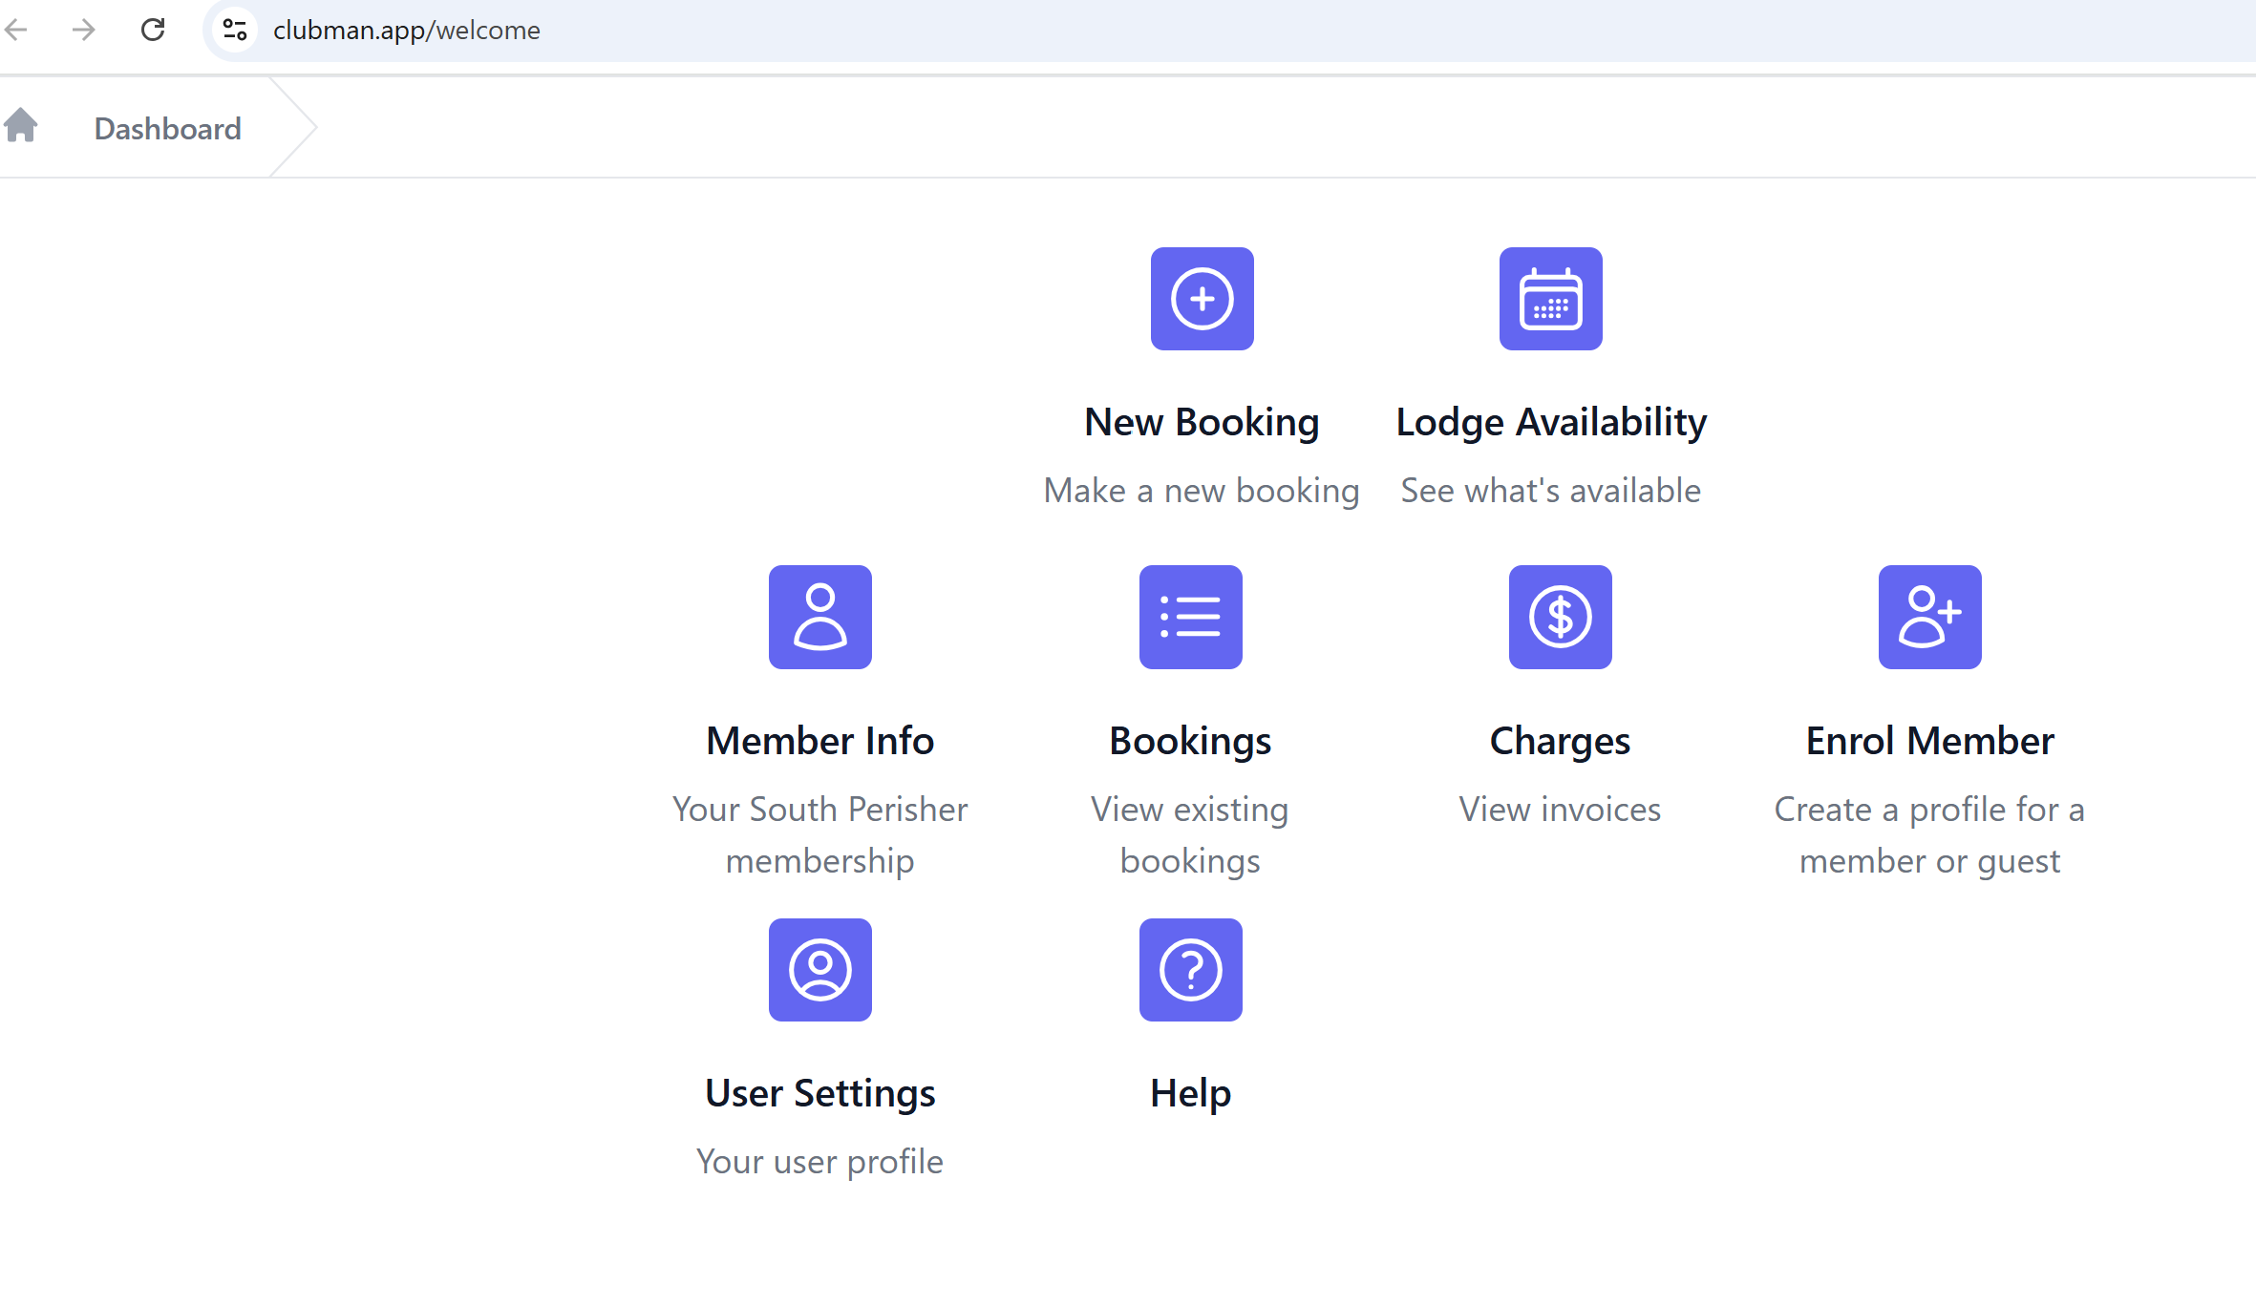
- How to check your subscription (1st Instalment) has been paid
You will be unable to make a booking if your first subscription instalment due on 31 March 2025 has not been paid. You should have received an email from Clubman with a link to your invoice to be paid. If you have any outstanding money owed to SPCAC it will be shown under the Charges icon as outlined below.
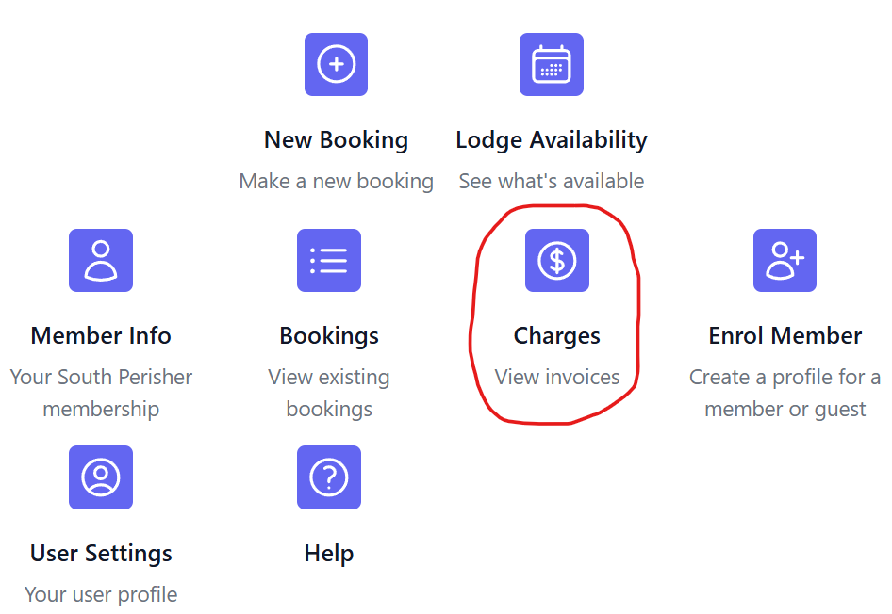

- Validating your Member information
To validate your Member information, please select the Member Info icon as shown below.
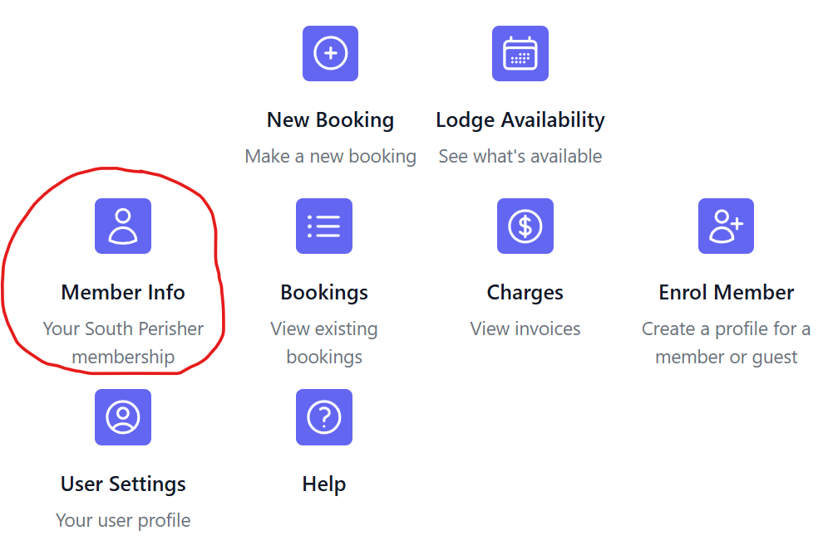
Please review and update any information that needs correcting. You will see that you have both a Member ID and a Share No.
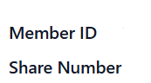
The Member ID is simply an alphabetical number that is assigned to all Unitholders. Your Share Number is based upon your original share certificate number.
Please complete any outstanding items in the table and save your changes.

- How to enrol Family Members
You must enrol Family Members before you can book them into the lodge. Family Members are defined as the Member whose name is first on the Share Certificate (Unit Holder), their spouse or de facto, all their children, their children’s spouses or de facto’s and grandchildren (It does not include boyfriends or girlfriends of adult children).

To enrol your family members, click on the Enrol Member icon as shown below, and complete all required fields.
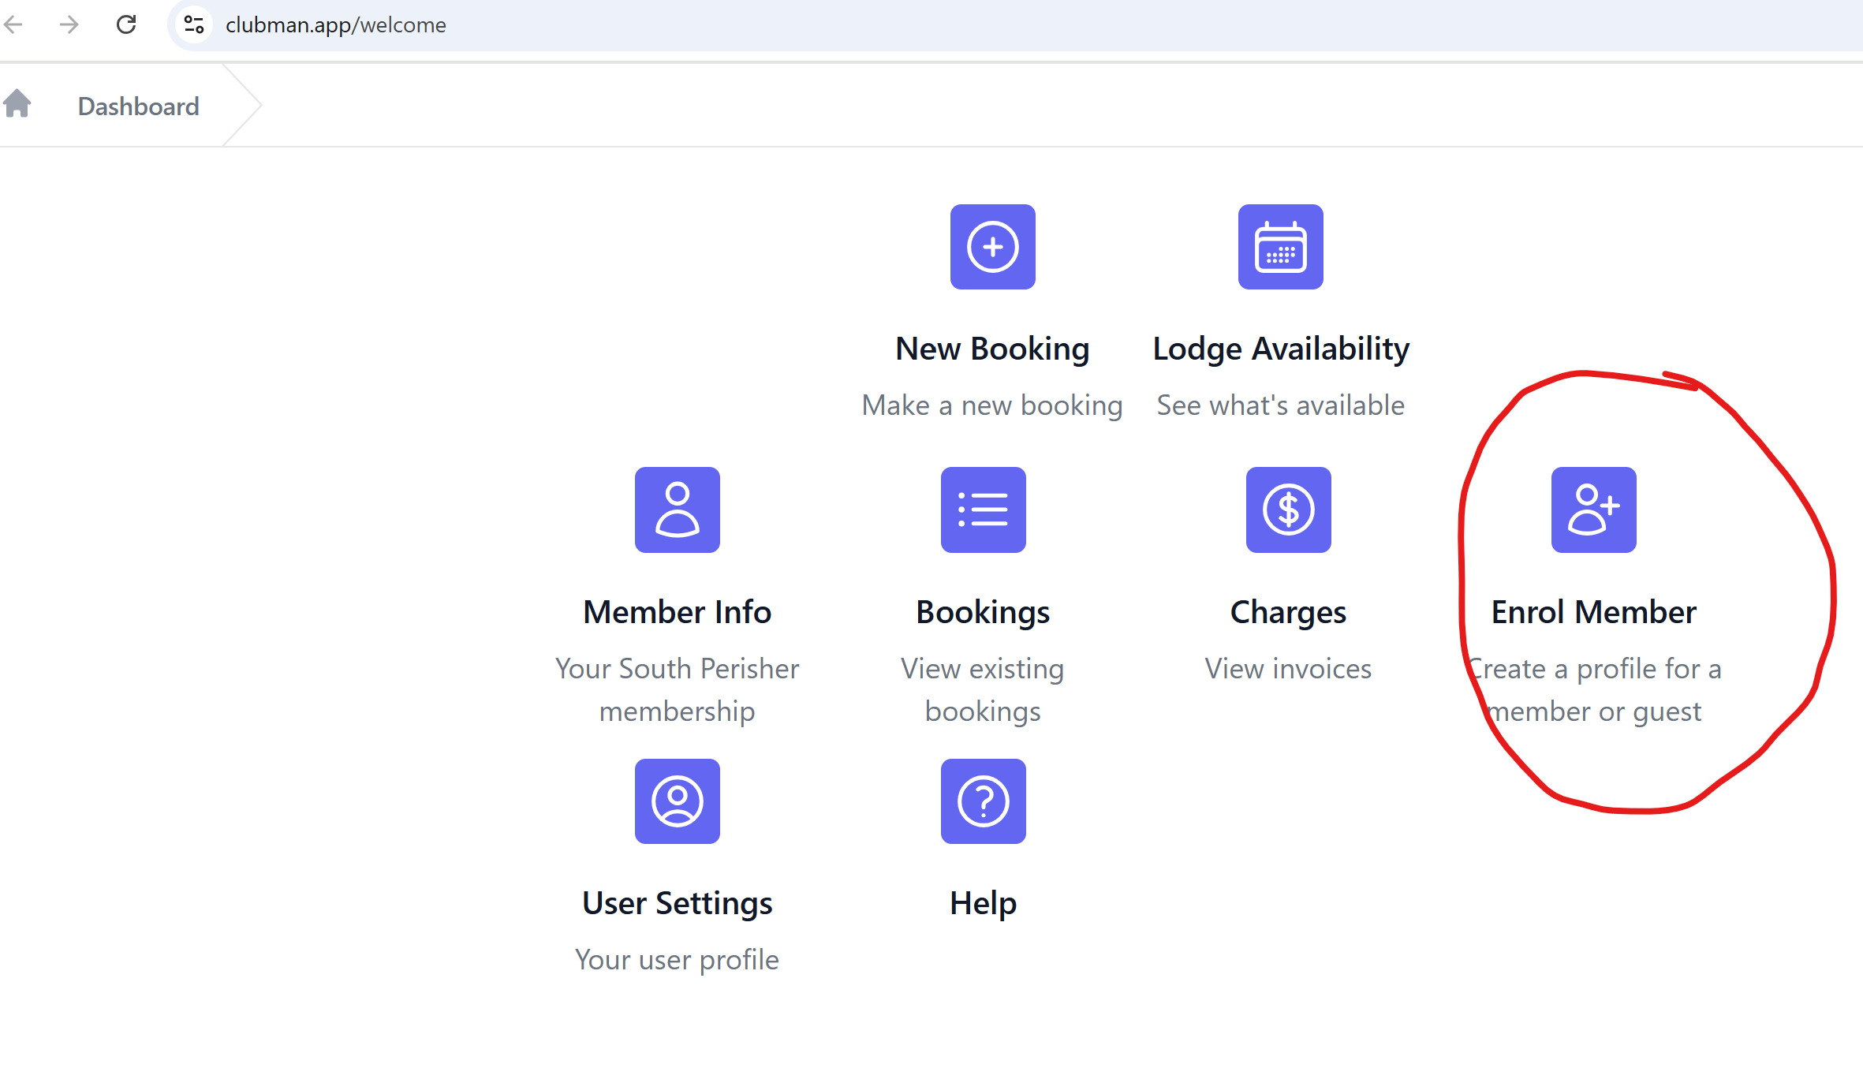

Date of Birth
Birth dates need to be entered into Clubman for everyone. This is to enable the system to determine the appropriate charges to be applied to the booking and for data analytical purposes. Children under the age of 5 also need to be identified in the statistics provided to the NSW National Parks and Wildlife Service which is a requirement under the SPCAC lease. Children under the age of 5 are free.

Class
There are three classifications for Class
- Unit Holder (You)
- Unit Holder Family (Spouses/De Facto, Children, Children’s Spouses and De Facto’s and Grandchildren)
- Guest (everyone else)

Unit Holder Family Member Relationship
Please use the following classifications when enrolling family members
- Unit Holder (Already classified)
- UHSD (Unit Holder Spouse or De Facto)
- UHC (Unit Holder Child)
- UHCSD (Unit Holder’s Child’s Spouse or De Facto)
- UHGC (Unit Holder’s Grandchild).
Please complete all phone numbers and email addresses for adult children to enable the Booking Officers to contact them if required.

- How to check room availability
Before making a booking, you can check room availability by clicking on the Lodge Availability icon.

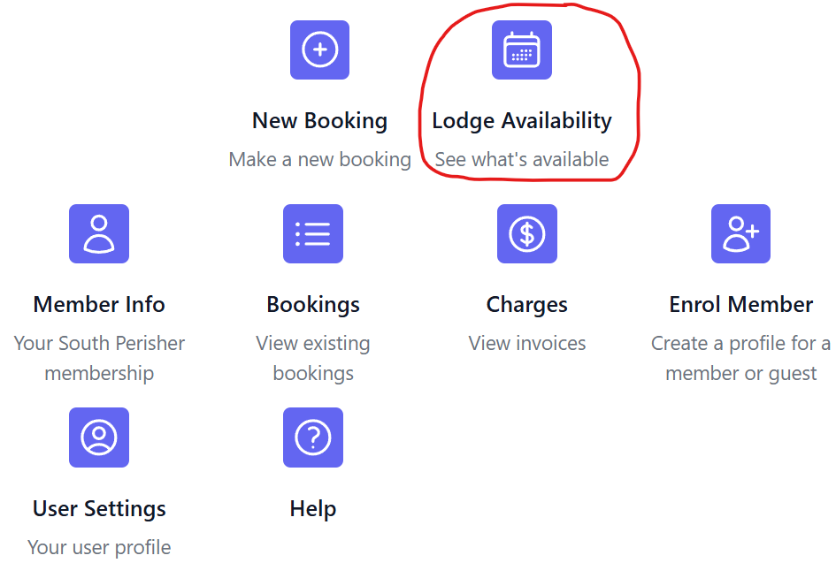

You can type in a date range to view entire months or just a single week.

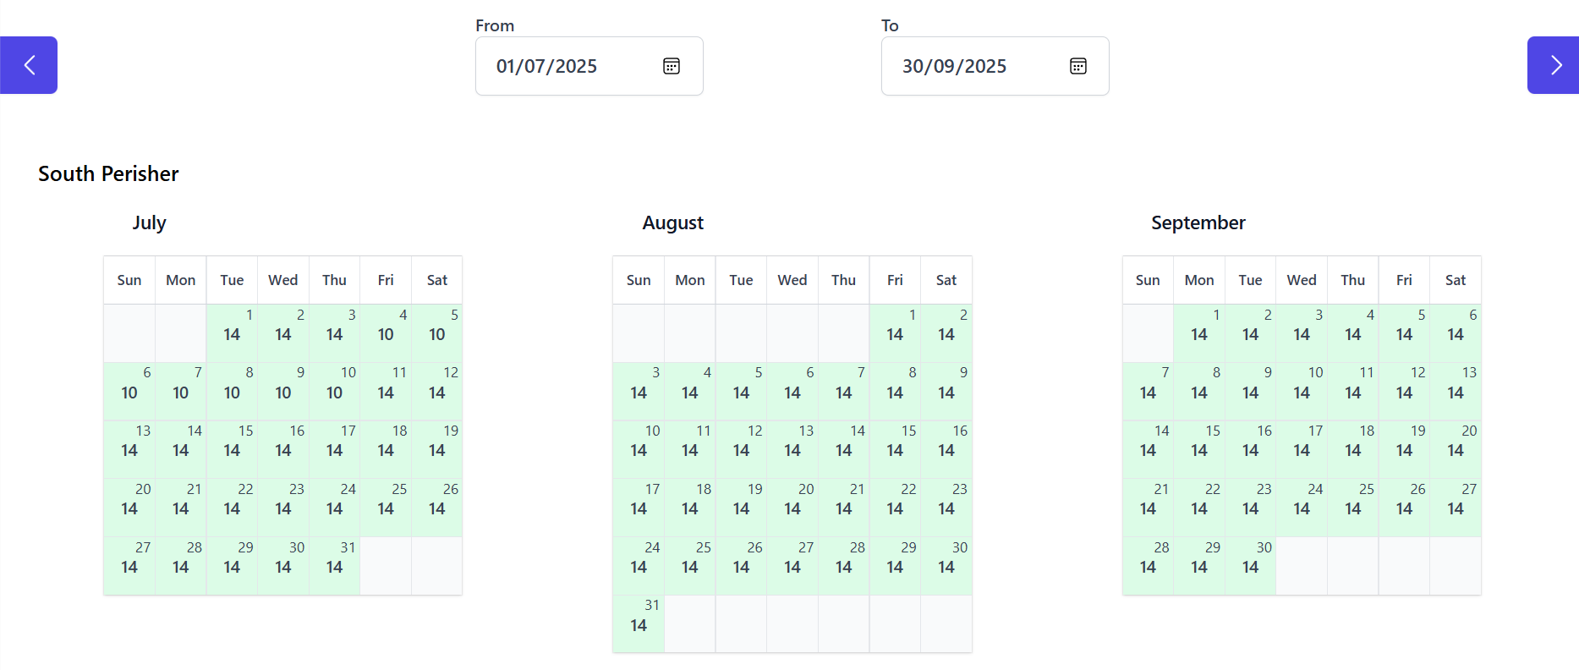

- How to make a booking
Once you have checked availability, click on the New Booking icon as shown below.

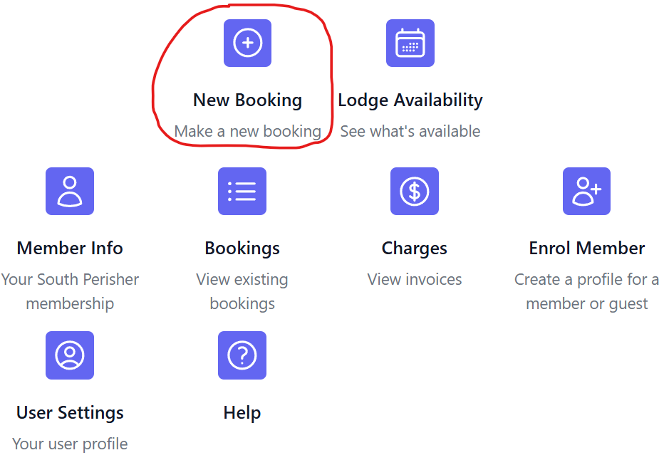

Type in the dates you are interested in using the calendar. Green means the bedroom is available while orange and red indicate a booking, filling some or all beds. You can view people already booked into the lodge by clicking on the link on the bottom right-hand side as shown below.

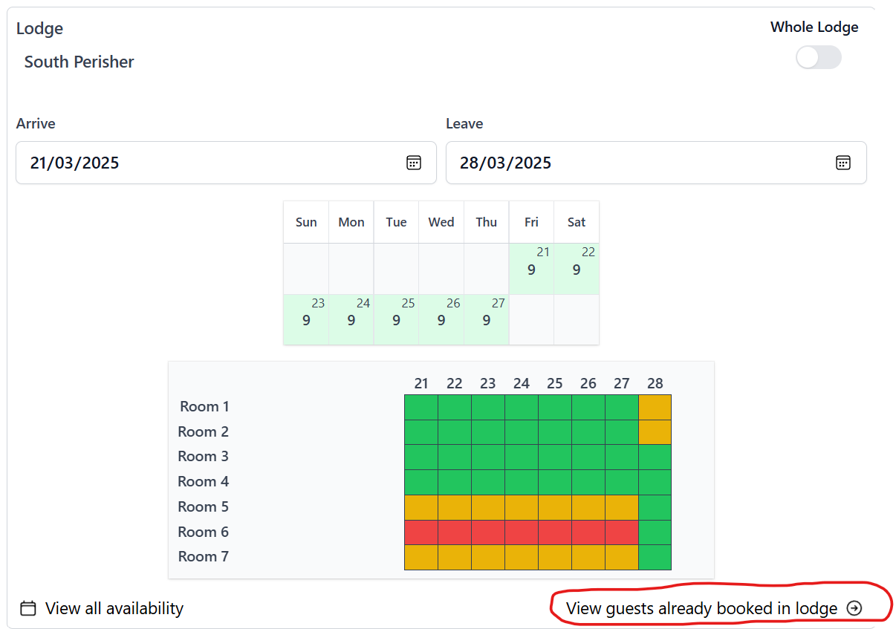
- Select who you would like to bring, by clicking the drop-down menu below “Guests” (in the broader sense of the definition) coloured in yellow below. You can add multiple people to your booking and they will be listed below the box for your reference. You can also add people to your dropdown list by selecting the Enrol new guest button (circled red below).

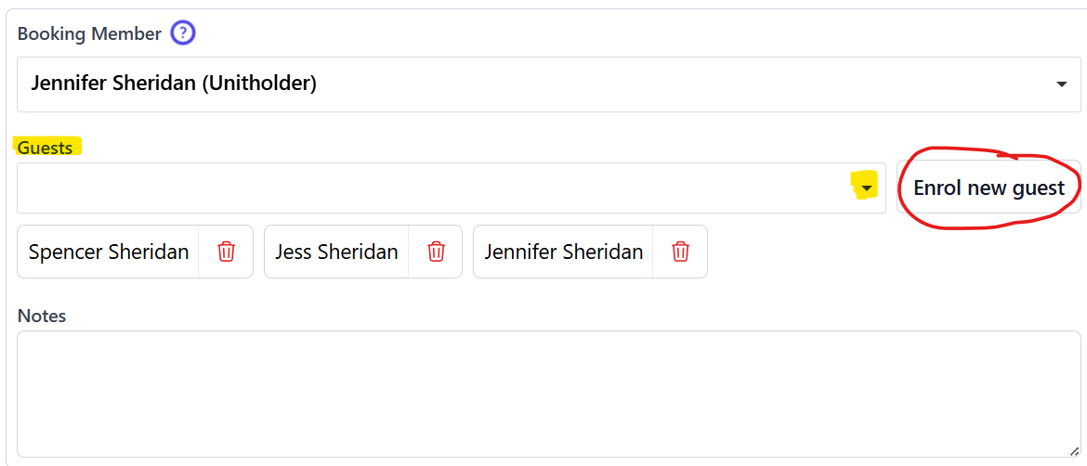

- Please note you will need to comply with the new Booking Rules. In the earlier booking periods, some constraints apply such as a Unit Holder with family being unable to invite Guests until the General Booking Period opens (Please refer to the new Booking Rules).

- Once you have added attendees press submit and you will be shown
  - The booking cost
  - The number of beds required
  - Arrival and Departure dates (In peak and economy winter seasons this is primarily 7 nights from a Friday)
  - A request to select bedrooms.

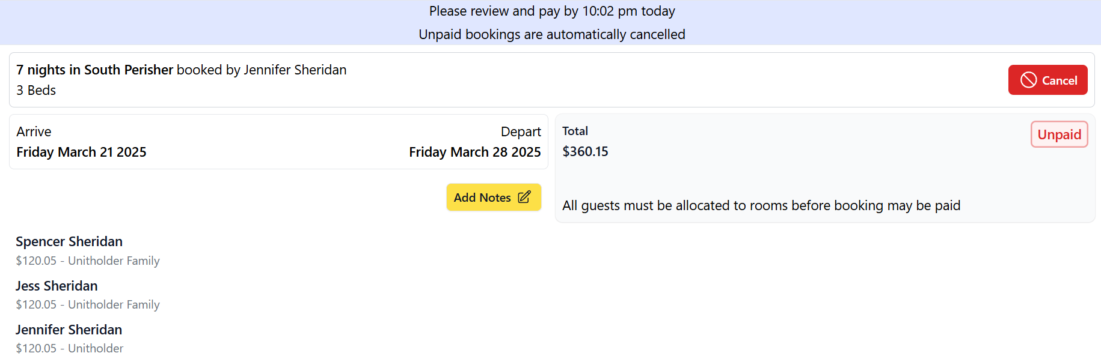

Selection of bedrooms
Scroll down the page to select rooms using the arrow (circled in red below). Choose the required room/s and these will be shown in calendar view and just above the Select Room title. It is preferred that family members share rooms where practical.

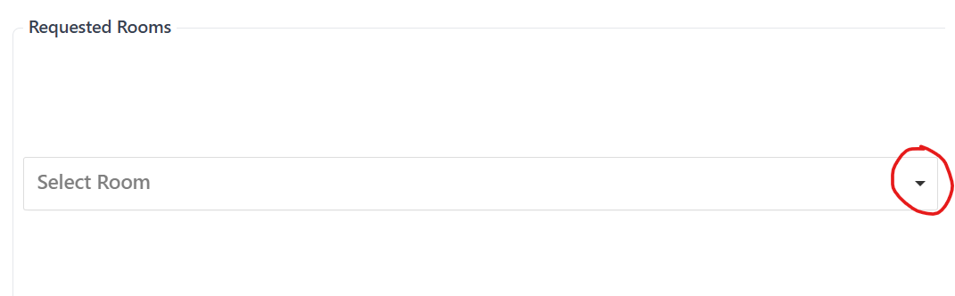
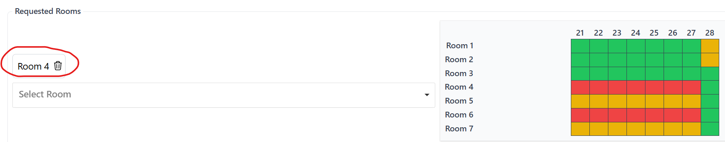The club in peak times reserves the right to review room allocations and move people to a different bedroom to the one they may have selected to maximise lodge capacity. However, Members affected will be consulted before any changes are locked in.

- How to pay for a booking
After you have selected your room/s they will show up next to your member/guest names. The system will automatically include a reserve bed/s to ensure your bedroom is private.

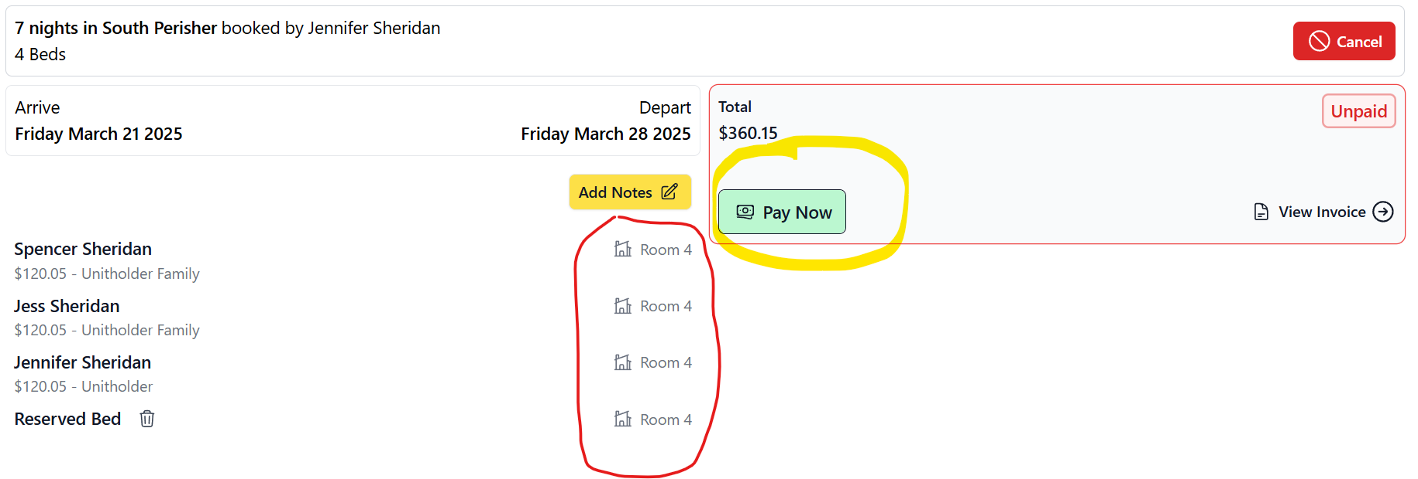

To confirm your booking, you will need to pay within 1 hour. To pay, select ‘Pay Now’ and Clubman will request you add a new payment method. Clubman will also send you an email at the time of booking requesting you to pay quickly (with a payment link) or your booking will be cancelled as shown below. Clubman accepts both debit and credit cards.

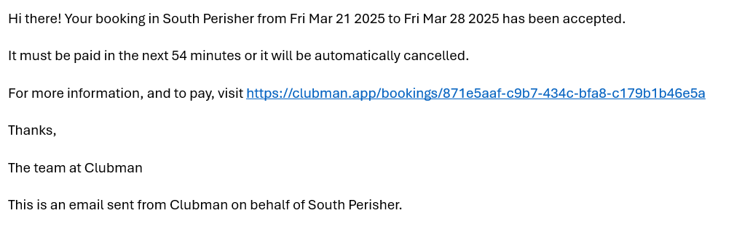

- Further assistance
If you have difficulty using Clubman, this YouTube clip Making a booking runs through the procedure. If you require additional assistance, a WhatsApp booking group has been set up to help members through any teething problems. You can connect using the below link. https://chat.whatsapp.com/BSmTYxSMAfK2popttPOYOd and the Online Booking Committee will get back to you ASAP.

If you are unable to book online due to connectivity or have other issues, please send your booking form to bookings@southperisher.org.au

